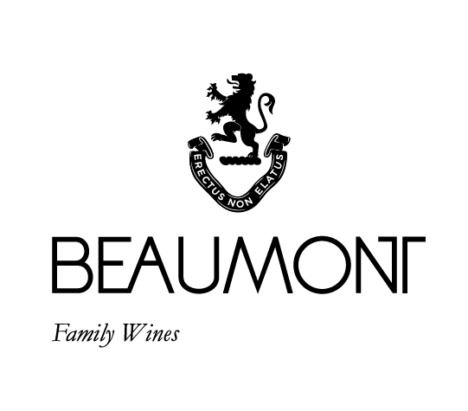

CAPE WHITE (Port style) | 2022

Way back in 2013 we had a young guy called Alvaro Roseira from the Douro valley in Portugal helping us for the vintage. Alvaro was one of those remarkable characters who was always enthusiastic about life on all levels. He inspired the making of our first white port.

The 2022 is the third Cape white we have produced. Foot stomped Chenin Blanc grapes, fermented on the crushed skins and stalks for a few days and then fortified. Matured for three years in an old white wine barrel and then bottled. A wine with a lovely balance that is not too sweet. It is full of dried fruit flavours, a long finish and a silky-smooth finish. It is delicious on its own (nicely chilled) or blended with some tonic, ice and a slice of orange – our “Pour a Tonic”.

FOOD PAIRING | A few different ways. As an aperitif mixed with tonic and a peel of lemon or orange. Neat on its own slightly chilled. Or have it with some lovely cheeses at the end of a meal. Especially Queso de Serra if you can find one in Portugal.

RATINGS & REVIEWS | Not rated or reviewed

PACKAGING | 6 x 375 ml with gift box option.

BOTTLES

PRODUCED

930 x375ml

pH

3.62

RS

52.2 g/l

TA

4.9 g/L

ALC

16.81%

BALLING AT HARVEST

25° Balling

YIELD

4

tons / ha

VINEYARD

AGE

.

46 yrs

APPELATION

Bot River

CULTIVAR

100% Chenin Blanc

WINE MAKER | Sebastian Beaumont.

VINTAGE CONDITIONS | A normal wet cold winter allowed for good rest of the vines. Healthy ripening season produced perfect grapes resulting in fantastic juice.

VINIFICATION | Chenin foot stomped at our annual port stomp. Then fermented on the skins and fortified once the sugar had dropped enough. Pressed and racked to barrel for 3 years maturation.

MATURATION | 3yrs in oak

AGEING POTENTIAL | 10-15 years.