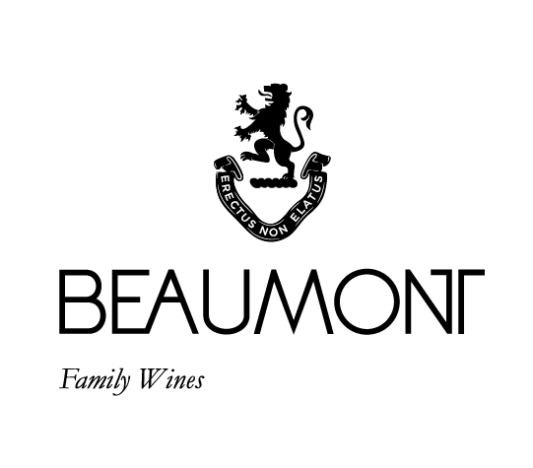

VITRUVIAN BLEND | 2020

Why Vitruvian? The key component of our 250 yr old water mill is known as a Vitruvian Mill. We wanted to connect this unique wine to the history of the farm. The Beaumont family have been farming the vineyards on the farm since 1974 and it is with this experience and understanding of our unique terroir that we decided to produce this special blend. Our philosophy with all our wines is to produce a pure expression of place. We prefer elegance over power and want this blend to be the sum of its component parts. 60% of the 2020 blend was co-fermented to allow the varietals to integrate from a very early stage.

FOOD PAIRING | Coq au vin, Italian sausage pasta, or a great piece of steak with spices such as cumin, pepper and coriander enhancing the natural spice of the wine.

PACKAGING | 6 x 750 ml

RATINGS & REVIEWS | The first vintage produced from the 2006 crop and this wine received fantastic reviews. Elegance was one of the main factors behind this blend. The 2020 vintage received 93 points in the Platter wine guide.

BOTTLES

PRODUCED

1985 and 20 magnums

VINEYARD

AGE

.

17 - 47 yrs

CULTIVAR

32% Syrah

29% Mourvèdre

23% Pinotage

11% Cab Franc

3% Petit Verdot

pH

3.56

RS

1.3 g/L

TA

5.7 g/L

ALC

12.82%

BALLING AT HARVEST

23° - 24.5°

Balling

YIELD

3 - 5

tons / ha

APPELATION

Bot River

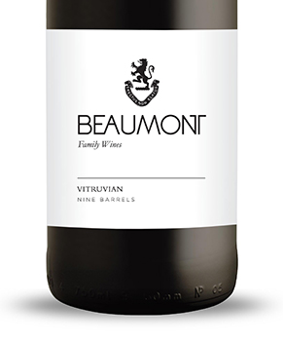

WINE MAKER | Sebastian Beaumont.

VINTAGE CONDITIONS | Gentle dry vintage which produced very open and full wines with great flavours and gentle tannins

VINIFICATION | We co-fermented 60% of the key components of this blend. The aim was to get very early integration of the varietals. The other 40% of the blend was kept as separate portions and blended in over time.

MATURATION | 8 x 225L barrels made & matured for 36 months in French oak of which 35% was new.

AGEING POTENTIAL | 10 - 15 years.