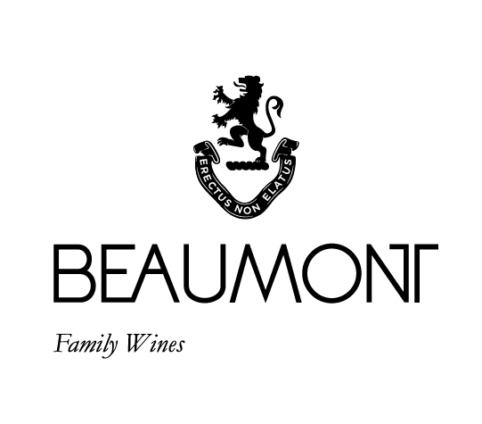

CAPE VINTAGE PORT | 2020 | Foot stomped |Two barrels

Our Port was made in true Beaumont style… stomped by foot! A blend of Pinotage, Syrah and Petit Verdot, picked at about 26°Balling, crushed by foot in open concrete tanks and matured in French barrels. Intense crushing of the skins resulted in aromas of cinnamon, blueberry and blackberry combined with a focused tannin structure. Unfiltered and unfined as per the 'traditional' style, with minimal sulphur use.

FOOD PAIRING | Goes well with dessert, especially dark chocolate or fruit desserts, walnut tart, nuts or fruity Christmas cake. Another great suggestion would be hard, flavourful, ripe cheeses.

PACKAGING | 6 x 375 ml

BARCODE bottle 6009077000382 box 16009077000389

RATINGS & REVIEWS | We make too little of this to be rated. Platter gives it 4.5 stars. We love celebrating the traditional style of Port and the celebration of wine. That is why we make it.

CULTIVAR

Pinotage, Syrah and Petit Verdot

VINEYARD

AGE

.

45 yrs

BOTTLES

PRODUCED

1540 bottles

(2 barrels)

pH

3.61

RS

52.2 g/L

TA

5.7g/L

ALC

18.75%

BALLING AT HARVEST

26° Balling

YIELD

4 – 5

tons / ha

APPELATION

Bot River

Walker Bay

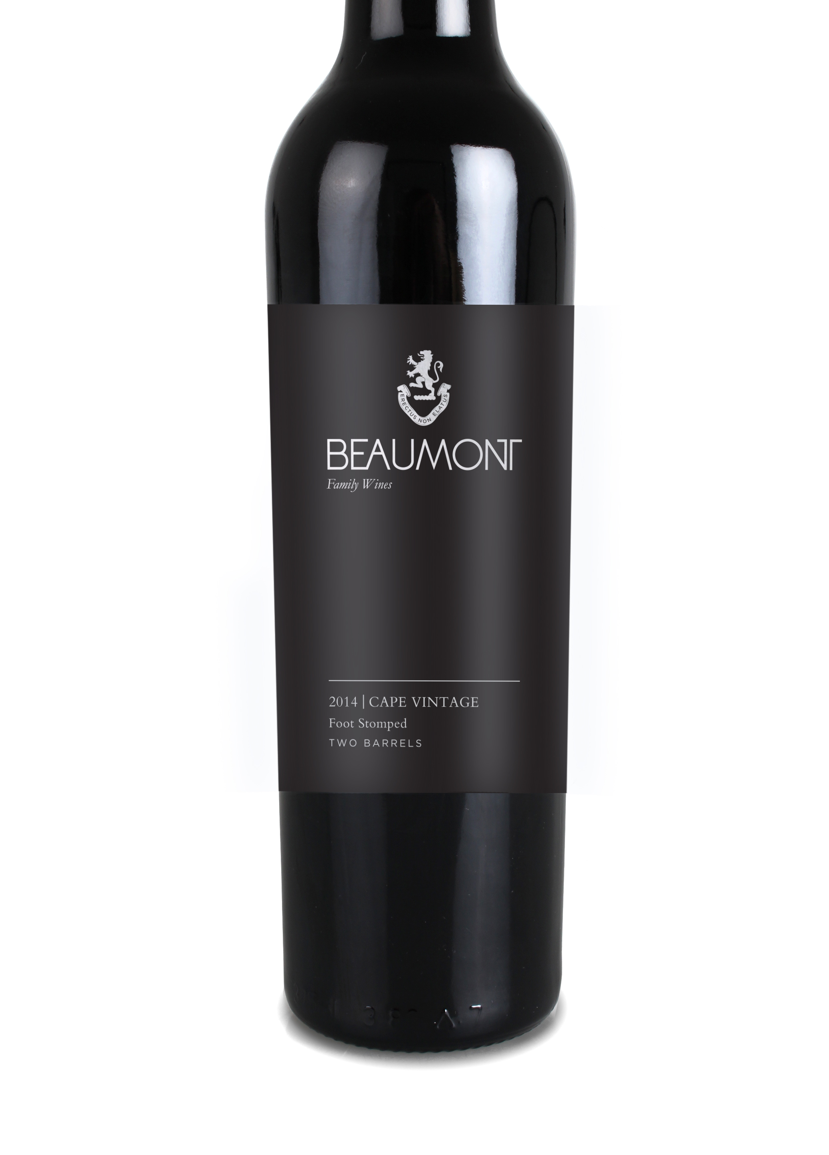

WINE MAKER | Sebastian Beaumont.

VINTAGE CONDITIONS | Reasonable temperatures during the final ripening stages allowed grapes to reach perfect ripeness without losing flavour and acid.

VINIFICATION | Grapes were traditionally stomped by foot in open plastic tanks to allow for maximum colour and tannin extraction. Inoculation was done after two days of skin maceration. After a few days of regular punching down the wine was hard pressed at 11° Balling and fortified at 9° Balling. Maturation took place in 10th filled French Oak barrels for four years. No fining and no filtration.

MATURATION | Three years of maturation in 10th filled French oak barrels.

AGEING POTENTIAL | 10-15 years.